**PARTH CHANDGADHIYA 300986134**

**Answer 01**

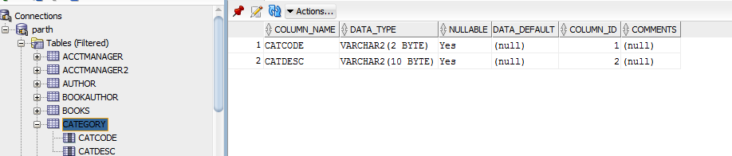

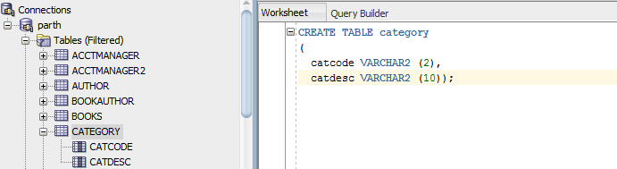

**Answer 02**

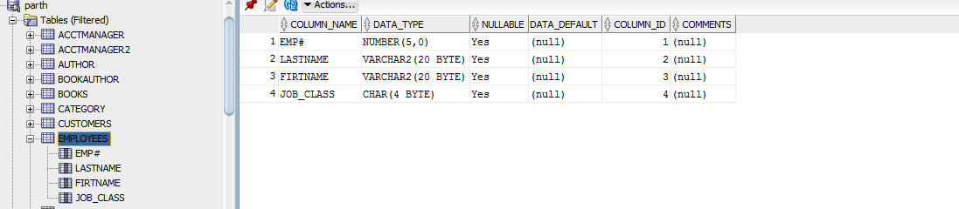

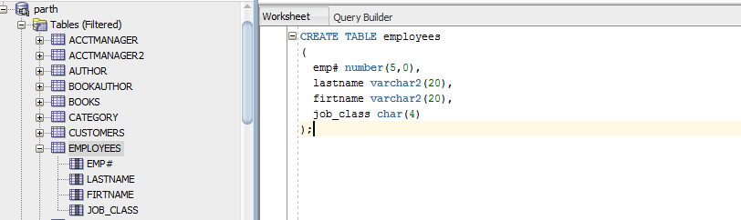

**Answer 03**

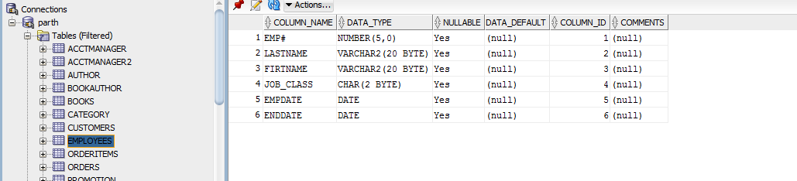

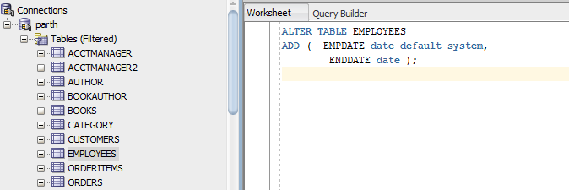

**Answer 04**

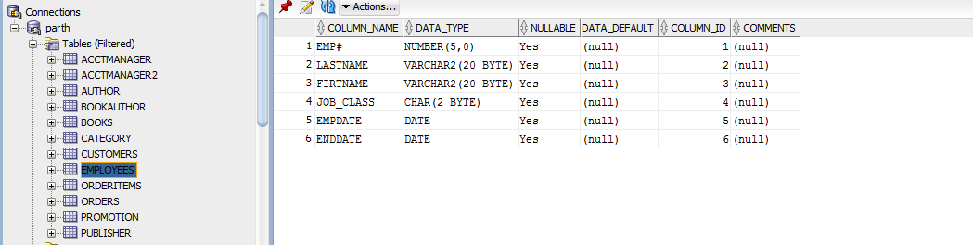

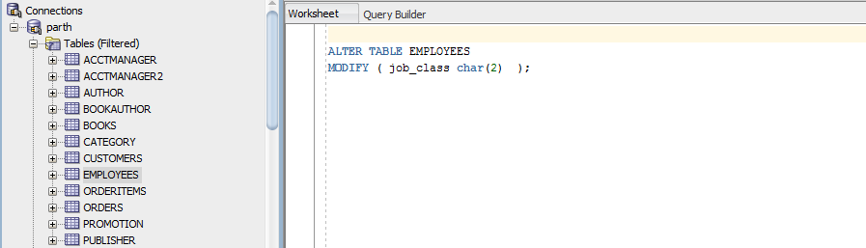

**Answer 5**

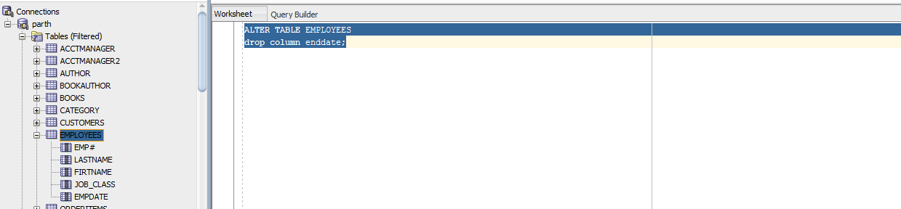

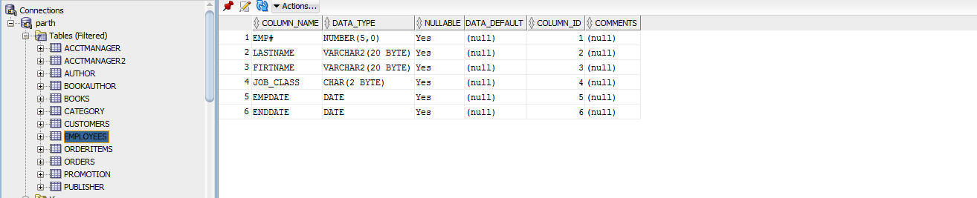

**Answer 6**

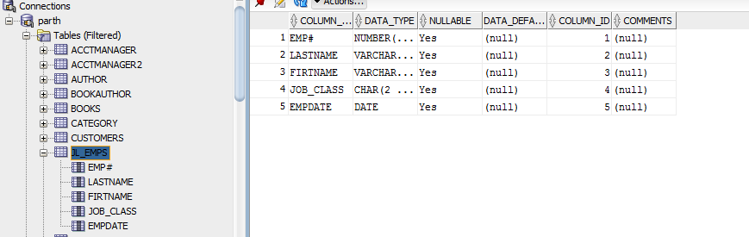

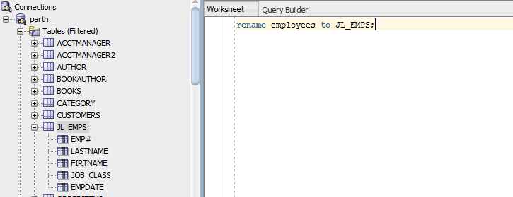

**Answer 7**

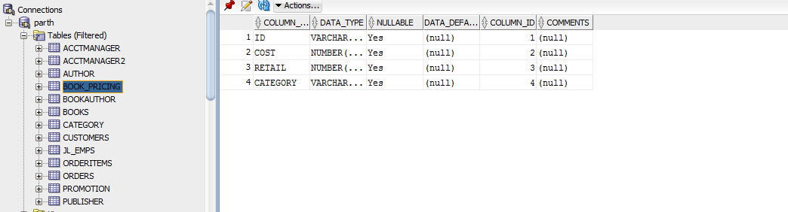

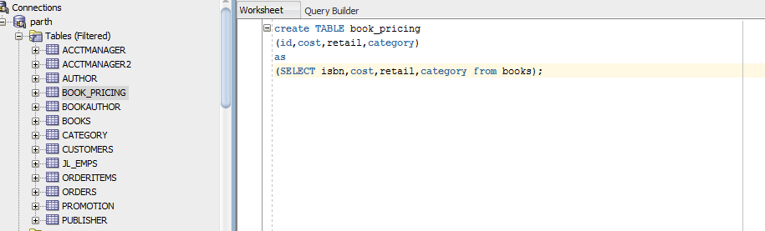

**Answer 8**

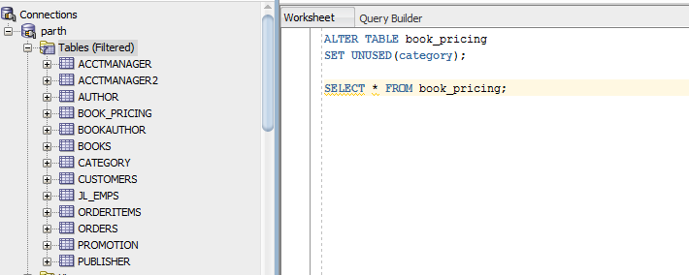

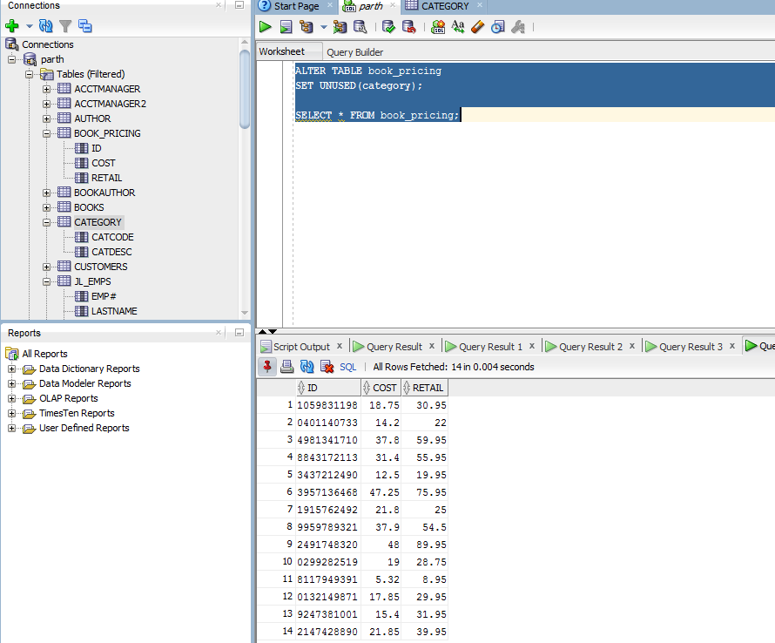

**Answer 9**

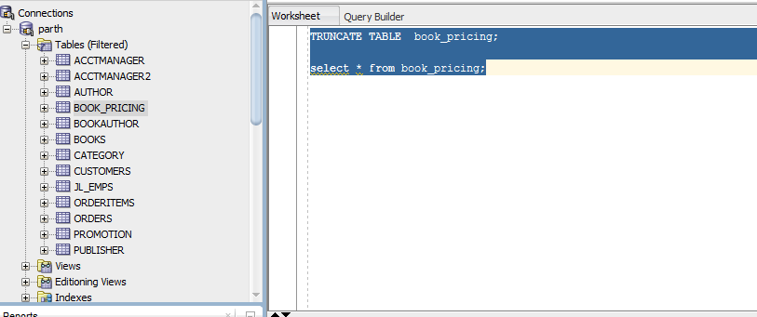

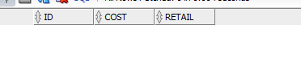

**Answer 10**

